Module 10 LASER
SPEAKING
- Ask and answer questions to find out missing information
- Speak about real and imaginary conditions
- Speak about future applications of laser

LISTENING
- Listen to part of a lecture on laser properties

READING
- Read about laser applications
- Read about laser timeline
- Read about laser history
- Read about pioneers in laser research
- Read about the laser future applications

WRITING
- Write a paragraph about accidents involving laser

VIDEO CONTENT
- Laser history
- 5 ways laser will be used in the future

Grammar
- Conditionals 1-2-3
- Conjunctions to introduce conditionals: IF, UNLESS, IN CASE, PROVIDING/ PROVIDED (THAT), ON CONDITION THAT, AS/ SO LONG AS
- Inversions in conditionals: SHOULD (YOU), HAD (YOU)
- Phrases with AT

Word formation:

Essential vocabulary
amplify, v | employ, v | increasingly, adv | pave (the way), v | reveal, v | trigger, v
award, v | expand, v | machine, v | propose, v | scale, n | unless, conj
beam, n | fibre/ fiber, n | matter, n | provided/ providing, conj | semiconductor, n | via, prep
condition, n | fine, adj | measure, v | ray, n | sync, v | wavelength, n
construct, v | groundbreaking, adj | melt, v | refine, v | tiny, adj | weld, v

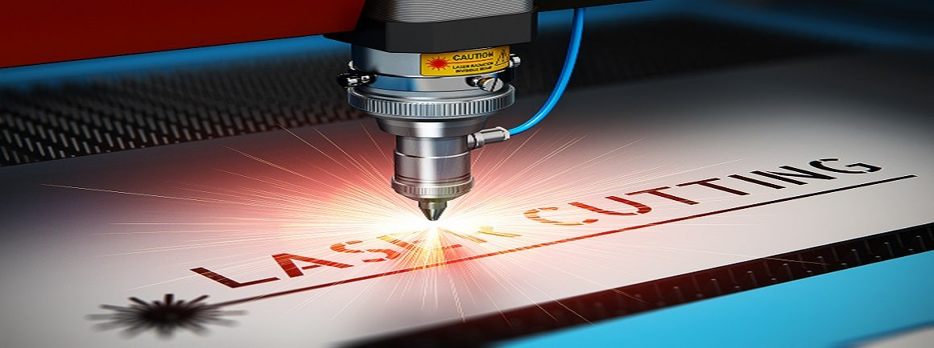
Lesson 1 LASERS EVERYWHERE
1 Look at the pictures and match a conventional device with its laser equivalent.
What are their functions?
E. G. [a] and [b] are both used for measuring distances/ to measure distances.

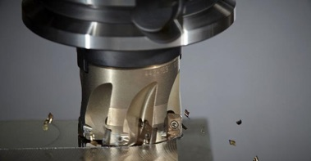 | 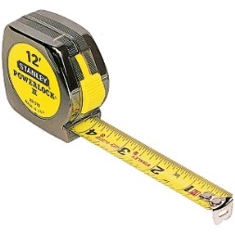 | 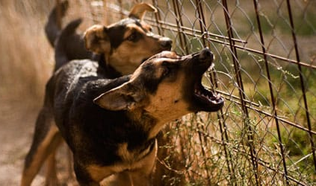 | 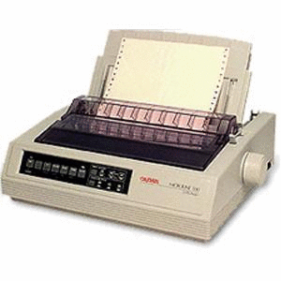
a | b | с | d
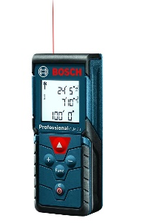 | 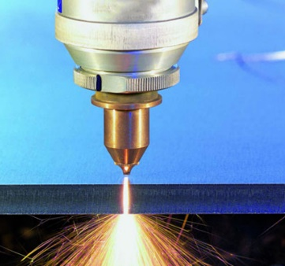 | 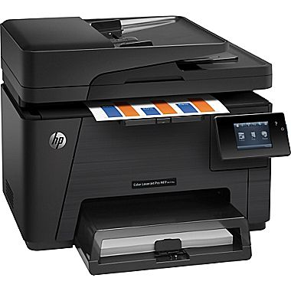 | 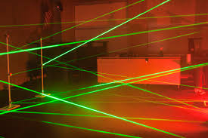
e | f | g | h

What advantages do laser devices have? (cheaper; faster; more accurate; more efficient etc)
What other laser devices do you know?

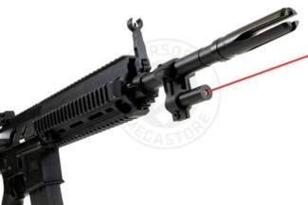 | 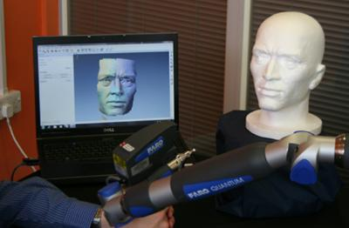 | 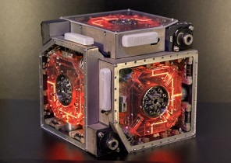 | 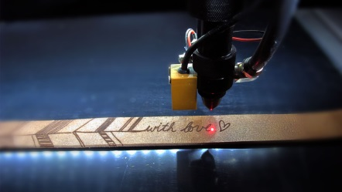

3D laser scanning; laser barcode scanner; laser cutting; laser drilling; laser engraving; laser gyroscope; laser intruder alarm; laser lighting display; laser measure; laser pointer; laser printer; laser rangefinder; laser speed gun; laser sight; laser welding; lidar
2 *Fill in the gaps with the names of laser devices from the box above.
_________ (Light Detection and Ranging) is a remote sensing method used to examine the surface of the Earth.
Laser _____ is a manufacturing technique to join two or more pieces of material (usually metal) together using a laser beam.
Laser ______ is a device on a firearm that uses a laser to take a precise aim.
Laser____ ___ is a handheld device used by the road police to measure the velocity of a vehicle.
Laser________ an instrument for finding the distance of an object from the observer.

3 Find the English equivalents.
Дальномер; лазерная указка; лазерный прицел; лазерная сварка; резка лазером; лазерная гравировка; сканер штрих-кода; лазерное шоу.
4 Answer the questions and do the reading task.
1. Some people say that laser is more present in our life than a wheel. Do you agree with this? Name the spheres where laser is used.
2. Read the texts below and match the paragraphs to the headings. Note! One paragraph is extra
Information Technology Manufacturing Measurement and analysis
Medicine Military Scientific research Telecommunications

semiconductor, n – полупроводник, полупроводниковый
fibre (fiber), n – волокно
via, prep – через, посредством
amplifier, n – усилитель
amplify, v – усиливать, увеличивать
fine, adj – тонкий, мелкий
beam, n – луч, пучок лучей
increasingly, adv все чаще
melt, v – плавить, расплавлять
employ, v – использовать
measure, v – измерять
tiny, adj – крошечный; миниатюрный
matter, n – материя
reveal, v – выявлять, обнаруживать
scale, n – масштаб

Information Technology
One of the application of lasers is in optical storage devices (e.g. CD and DVD players), in which a focused beam from a semiconductor laser, less than 1 mm wide, scans and reads the disc surface. Other everyday uses include barcode readers, laser printers and laser pointers. Over the past 25 years the publishing and newsprint industries have been revolutionised by the use of lasers, which have replaced traditional “hot metal” printing.

______________  Another large application is in fibre-optic communications. Broadband* depends on the transmission of light pulses along optical fibres, which are generated and sent via lasers. This is made possible by fibre amplifiers, which are an important component in long-distance fibre links. | * широкополосная сеть
_______________  Lasers can deliver concentrated energy in the form of fine controllable light beams, so doctors soon took advantage of them to perform micro-surgery, which involves less pain and scarring*, lower blood loss and shorter recovery time in hospital. One of the most frequent uses of lasers is in eye surgery to treat disease and, increasingly, improve bad eyesight. | * образование шрамов
________________
Lasers can deliver enough power to heat and melt metal joints, and so are used for welding, as well as for cutting. When controlled by a computer, a laser can cut complex designs into a material such as wood or paper, as is increasingly being seen in furniture and other home goods.

________________  Lasers have long been used by the military for range-finding, but now even estate agents* employ laser tape measures. Because lasers can be modified to produce specific wavelengths**, they are used to analyse chemical and physical structure, and so are used in factory quality control and to monitor environmental pollutants remotely. Lasers can be used for a type of measurement called interferometry which can measure tiny changes in distance. | *риелторы  ** длина волны
________________  Without lasers, many recent discoveries would never have been made. Lasers interact with matter at the quantum level in very specific ways and so are important tools in research. They can be used to follow chemical reactions and reveal structure at the atomic and molecular scale. Increasingly, life scientists are employing lasers in new types of microscopy designed to highlight cellular* structures. | *клеточные
5 Read the texts again and answer the questions.
- Which method was used in printing industry before laser?
- In what form is signal transmitted in fibre-optic cables?
- What are the advantages of laser surgery over the traditional technology?
- What manufacturing processes can be performed using laser?
- How can lasers be useful for environmental protection?
- How is laser used in science?
- What are the main properties of laser?

6 Match the synonyms.
- amplify | - use
- employ | - show
- fine | - soften
- matter  - measure | - calculate  - thin
- melt | - substance
- reveal | - using
- semi- | - make bigger
- via | - half

7 Translate into Russian.
Amplify a signal; amplified speakers; amplifying element; employ remote control; extra-fine; fine adjustment; fine print; antimatter; melting point; melted metal; revealed defect; revealing reagent; semi-automated system; tiny particles of matter; communication via satellite.

8 Study the phrases with the preposition AT and translate the Russian phrases.

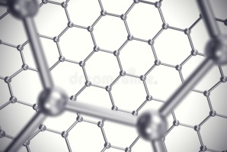
at quantum level
at atomic scale
at [this] speed
at [this] temperature
at [this] pressure

На низком уровне;
при комнатной температуре;
на высокой скорости;
при повышенном давлении;

GRAMMAR
9 Read the text and give examples of laser technology in your life
LIFE WITHOUT LASERS?
If you were offered $1000 to go an entire day without interacting with lasers, do you think you could do it? What if you also couldn't use anything that had been built with the help of lasers? Doesn't sound too hard, does it? Think again. If you lead a normal life and use some of the modern amenities around us, you inevitably come into contact with products that were created with or contain a laser. "How can this be?" you might ask. "I don't see any laser beams flashing around me. I don't hit an 'ON' button on a laser every day." But if you stop and think about all the uses lasers have, you'll be pretty surprised.... (By Mark Bronski)

CONDITIONALS
тип | значение | часть с if (условие) | главная часть (результат) | перевод на русский
Zero  0 | 100% истинно | present (simple, continuous, perfect) | present (simple, continuous, perfect) | настоящее время
 |  | If you heat water, | it boils.
First  1st | вероятное действие в будущем | present (simple, continuous, perfect) | future simple | будущее время (обе части)
 |  | If you keep trying, | you will succeed.
Second  2nd | маловероятное или воображаемое действие в настоящем | past simple | would v | с использованием частицы бы
 |  | If I were a magician, | I would make everyone happy.
Third  3rd | невозможное действие в прошедшем | past perfect | would have v3 | с использованием частицы бы
 |  | If your parents had not met, | you would not have been born.

10 Identify the types of conditionals in Text 9.

11 Match the two halves to make a proverb or a famous quote. Identify the type of the conditional.

- If I hadn’t been a writer,
- If there were no bad people,
- If wishes were horses,
- If you do right,
- If you do wrong,
- If you do what you always did,
- If you tell the truth,
- Even if I knew that tomorrow the world would go to pieces,

- you won't have to remember anything. (M. Twain)
- there would be no good lawyers. (Ch. Dickens)
- beggars would ride. (proverb)
- I would still plant my apple tree. (M. Luther)
- you’ll get what you always got.
- no one will remember.
- no one will forget.
- I should have been a gardener. (A. Chekhov)

12 Fill in the gaps with the appropriate forms.
a) describing what will happen if Oleg goes to bed late today
b) describing what would happen if Oleg went to bed late today
c) describing what would NOT have happened if Oleg had gone to bed earlier

If Oleg ________ (go) to bed late, he _________ (sleep in).
If Oleg ________ (sleep in), he ______________ (miss) his train.
If Oleg __________(miss) his train, he ___________ (be) late for the class again.
If Oleg _________(be late) for the class again, his professor ________ (get) angry at him.
If the professor ________ (get) angry at Oleg, he ______ (fail) him at the exam.
If Oleg ________ (fail) the exam, his parents ________ (be) disappointed in him.
If Oleg’s parents ________(be) disappointed in him, they _______ (not give) him any money.
If Oleg ___________ (not have) any money, he __________ (have) to find a job.
If Oleg __________ (find) a job, he ________ (work) long hours.
If Oleg __________ (work) long hours, he _________ (go) to bed late.

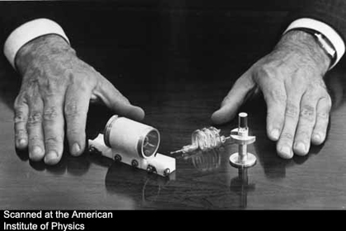
LESSON 2. SOLUTION LOOKING FOR A PROBLEM

13 Fill in the gaps with the suitable words from lesson 1.
- All m_______ is made up of t___ particles called atoms.
- Conventional commercial lasers can m____ a metal by a depth of 2 mm per pulse.
- One of the main benefits of laser w_____ is that it offers a high level of accuracy.
- Transistors are devices that can a_______ a weak signal in a circuit.
- Class IV lasers are e________ for surgery, cutting, drilling, and micromachining.
- Microf______ diameter is larger than 0.2 micron, but not larger than 10 microns.
- 3D maps created from aircraft-mounted lasers are helping to r______ historic secrets.
14 Answer the questions before watching the video. https://www.youtube.com/watch?v=JFThNvfKHck (from 0:50)

1. Who laid the foundation for the science of laser?
a. Isaac Newton b. Nicola Tesla c. Albert Einstein
2. When was the first laser constructed?
a. 1920s b.1960s c. 1980s
3. Laser was invented …
a. for a specific practical purpose b. without a definite practical purpose

15 Watch the video and match the personality with the achievement.

award, v – присуждать, награждать
beam, n – луч
pave the way – подготовить почву
propose, v предлагать
construction, v – сооружение, изготовление
groundbreaking, adj – революционный прорывной
trigger, v – инициировать, дать начало

 | 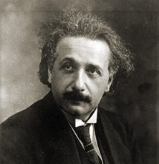 | 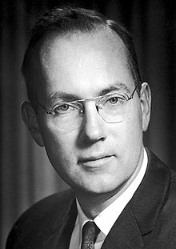 | 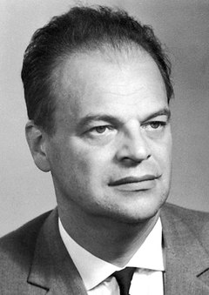 | 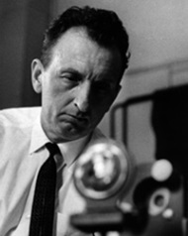 | 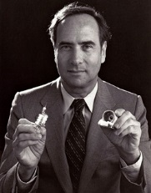
 | Albert Einstein | Charles Townes | Nikolai Basov | Alexander Prokhorov | Theodore Maiman
constructed the first working laser
described the basics of stimulated emission
laid the fundamentals of quantum physics
was awarded the Nobel prize in physics

16 Translate these sentences from the History of Laser video into Russian.
- A beam of light needs eight minutes and nineteen seconds to reach the Earth.
- The man who paved the way was Albert Einstein.
- By pure logic Einstein proposed that there had to be an until then unknown type of light emission that would allow us to control the characteristics of light to a degree that was not dreamt possible before.
- Four years later in 1921 he was awarded the Nobel Prize for Physics for his groundbreaking theories about light.
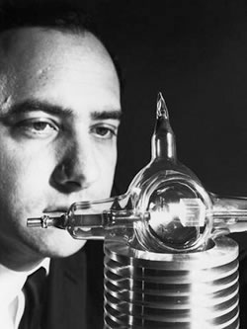
- One day Townes would study physics and his fundamental work in the field of quantum electronics enabled the construction of the very first masers and lasers.
- The laser was a groundbreaking technology that would find applications in every sector of modern life and activity. It was an invention that triggered innovations itself.
Theodore Maimain
- People still did not quite know what Maiman's new invention could be used for: “an invention searching for an application” was the scornful opinion even in the technical press.
17 This Laser Timeline contains 8 factual mistakes. Can you find them all?

18 Work in pairs. Ask and answer questions to fill in the missing information.
E.G. Who laid the scientific foundation for laser?
(It was) Einstein.
STUDENT A

The scientific foundation for laser was laid by__________.
Astronauts on the Apollo 11 space mission in 1969 used a laser to measure _________________.
Despite some lasers being hotter than the surface of the sun, they can be used to cool atoms when combined with a magnetic field.
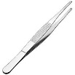
In 1974 lasers were used commercially for the first time in supermarket barcode scanners.
Laser “tweezers” can be used to manipulate _________.
Laser tag was developed as a training program for the U.S. army in the 1970s.
You need ________ common laser pointers to move a coin.
The strength of early lasers was measured in “gillettes,” the amount of power required to burn through one Gilette razor blade.
The capacity of the world’s most powerful laser is equal to ______________.

STUDENT B
The scientific foundation for laser was laid by__________.
The world’s most powerful laser has the power equivalent to that of a hydrogen bomb.
The strength of early lasers was measured in _________.
Laser “tweezers” can be employed to manipulate single atoms.
Lasers were used commercially for the first time in supermarket barcode scanners in ____ (year).
The Apollo 11 astronauts measured the distance between Earth and the moon using a laser in 1969.
____________ was developed as a training program for the U.S. army in the 1970s.
Lasers can be used to cool atoms when combined with _____________.
Lasers can be used to push an object! But you need at least 30 billion common laser pointers to move a coin.

GRAMMAR
CONDITIONALS 1 & 2
19 Work in pairs. Ask and answer questions.
- If you decide to eat out, which restaurant or cafe will you go to?
- How will you feel tomorrow if you run 5 km today?
- If you didn’t get any homework, how would you feel?
- If you had more free time, how would you spend it?
- If you have a day off on Saturdays, will you study more?
- What will you do if you see someone cheating?
- If your phone breaks tomorrow, what will you do?
- What medicine will you take if you catch a cold next week?
- What would your teacher say if you were always late?
- When will you go to bed if you are really tired tonight?
- Who will you ask for help if you have a problem?
- Would you ask your groupmates for help if you had a problem in class?
Alternatives to IF:
unless – если не | Do not operate this device unless you are 100% confident.
in case – в случае если; | Read the manual again in case you missed something.
providing/ provided (that) – при условии, что | The mechanism will keep working provided there is enough fuel.
on condition that – при условии, что | They spoke on condition that their names would not be mentioned.
as/ so long as – если | As long as there’s life, there will be hope.

20 Fill in the gaps with the appropriate conjunction
1. You need backup _________ something goes wrong.
a. in case | b. provided
2. We won’t believe you _______ you give us proof .
a. as long as | b. unless
3. ________ as the car is regularly maintained, you will not have any problems.
a. in case | b. as long
4. Personal protection equipment won't help ______ you wear it.
a. unless | b. providing
5. E-books are popular as ________ they are free.
a. long as | b. provided that
6. They will fund the project _________ they find it safe.
a. provided | b. unless
6. The production technology will be refined _________ it will not involve extra expenses.
a. until | b. providing
7. Bubbles of air will expand if you heat them, ________ the pressure remains constant.
a. as long as | b. unless

21 Find the sentences where the words in bold can be replaced by IF.
1. The discovery of the planet Neptune provided a proof of Newton’s law of universal gravitation. Laser technologies have provided various industries with solutions to numerous technical problems.
2. A website providing information about the product will be created. You can pass on to the second question providing you have answered the first one.
3. These equations are valid only on condition that the intensity the light absorbed is directly proportional to the emission intensity. Optimal materials are selected depending on conditions that the specified object must meet.
4. Replacement equipment will be available, in case immediate repair is impossible. Of the 12 organizations in case, only one meets all the criteria.
5. One project took almost twice as long as originally planned. If everything goes well, the process can take as long as three weeks. Laser weapon will be approved by law as long as targets are nonhuman.

22 *Read the texts about laser pioneers and choose the correct synonyms to the words in bold. Think of the suitable title for each story. *Prepare one of the texts for retelling.
_____________  Townes sent a short paper to the leading journal Physical Review but at the time of his trip to England he had not yet written a thorough theoretical description of what he had done. Therefore, he was astounded when a Soviet physicist named Alexander Prokhorov, speaking excellent English, preceded him in the conference by delivering a paper describing the theory of an ammonia maser, exactly the device Townes had used. Townes had never met Prokhorov before and did not dream at that moment that he would eventually share a Nobel Prize with him and his student Nikolai Basov for the development of lasers. After Prokhorov had finished his report Townes stood up and announced, “Well, that is very interesting, and we have one of these working.” He then described his recent work with an ammonia maser. | detailed or correct?  introduced or surprised?  was before or after?  at first or at last?  said or asked?
____________  It was the Russian physicist V. A. Fabrikant who first had the vision to propose the concept of a laser in 1940. Fabrikant stated the principles of a laser in a doctoral dissertation of 1939, and in 1951 he obtained for his work an “author’s certificate”. He not only elaborated the theory but he was the first to observe experimentally the amplification of optical radiation using a mixture of mercury vapor and hydrogen. He was a true pioneer. Maiman (the American who built the first laser in 1960) thought Fabrikant should have received the Nobel Prize instead of Basov, Prokhorov, and Townes. He said that when the Nobel Committee chose the trio over Fabrikant they “did not do their homework. It would have made more sense to recognize the Russian physicist Fabricant.” | = nerve or foresight?  = corrected or developed?  = leader or hero?  = to honour or to understand?
____________  In the 1950s Prokhorov’s lab at the Lebedev Physics Institute was doing rather conventional research which did not seem to be leading toward anything exciting. Prokhorov decided it was necessary to move in a different direction, to start working on induced radiation of gases. His assistants in the lab did not wish to do so, as they were working on their dissertations and did not want disruption. Prokhorov gave them a month to rethink their positions. When they refused, he went through the laboratory with a hammer and destroyed the instruments that were necessary for their current research. He then brought in new instruments and instructed the assistants to work on what he told them. There was a tremendous scandal, half of the researchers left, but the remaining ones followed Prokhorov on the work that eventually resulted in a Nobel Prize. | = traditional or innovative?  = help or pause?  = said yes or no?  = broke or fixed?  = big or small?

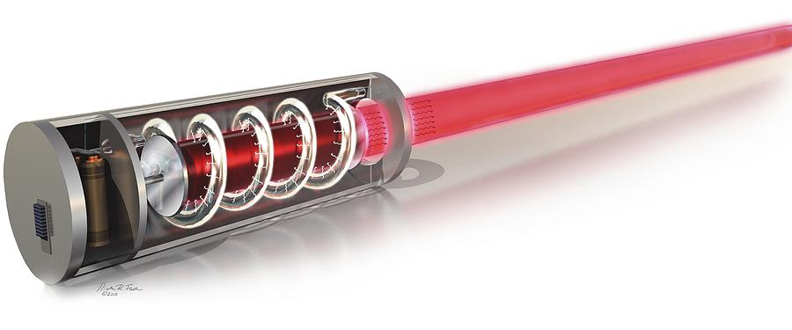

Lesson 3 HOW LASER WORKS
23 In each line find the one odd out.
 | employ | use | apply | find
 | expand | amplify | trigger | increase
 | refine | award | improve | upgrade
 | machine | process | construct | treat
 | propose | suggest | offer | employ
 | simulate | trigger | activate | stimulate
 | design | make | build | construct
 | conventional | groundbreaking | revolutionary | innovative
 | A. Einstein | L. Landau | V. Fabrikant | Ch. Townes

24 Listen and choose the correct laser property in each column.
1  - monochromatic  - monodramatic  - monogramatic | 2  - adherent  - coherent  - inherent | 3  - collected  - collimated  - contaminated

25 Listen again and choose the correct option in each statement.
Match them with the laser properties.
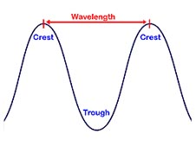
wavelength, n = the distance between two points of the same phase
ray, n = beam
sync, n = to be in phase = synchronize
crest, n = top, peak
trough, n [trɒf] = the lowest point of a wave

The white light/ laser light is composed of all of the wavelengths of light that we can see.
The white light/ laser light is composed of only one wavelength of light.
The laser/ ordinary light rays are far apart.
The laser/ ordinary light rays don't spread out but instead remain parallel to each other.
All the rays in a laser/ ordinary light beam are in phase, which means that their crests and troughs sync up.
The crests and troughs of the rays in a laser/ ordinary light beam do not sync.

26 Match the labels to the illustrations. Which of them show laser light?
coherent/ collimated/ incoherent/ monochromatic/ non-collimated/ polychromatic
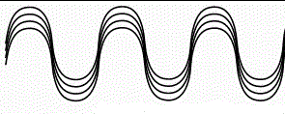 |  | 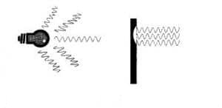
a | b | c
d | e | f

27 Read the text about how laser works and choose the correct alternative in each case.

To make a laser all you need to do is give a big collection/ connection of atoms enough energy so they're exciting/ excited and ready to emit/ exit light. Once/ Since one of them spontaneously/ simultaneously emits a proton/ photon, it'll motivate/ stimulate some of the others to do so and you get a nice cascade of illumination. But instead of letting all the light enter/ escape, it's more powerful to trap/ hide it between two mirrors/ walls and let it bounce back and forth through the atoms. All that passing light will simulate/ stimulate them to emit even more light. And as long as/ unless you keep on re-exciting the atoms they're happy to go on emitting light forever/ finally.

28 Watch the video (till 0:26) and check your answers.

29 *Read about the difference between beam and ray. Choose the correct variant.
- The direction of the path in which light is traveling is called a ray and is represented in diagrams by a straight line with an arrow on it.
- A beam is a stream of light and is shown by a number of rays; it may be parallel, diverging (spreading out) or converging (getting narrower).
https://socratic.org/questions/what-is-the-difference-between-a-ray-of-light-and-a-beam-of-light
- Rays are only discussed under light, but beams are discussed in both waves and particles.
- Wave properties such as wavelength, amplitude, and phase are omitted when a ray is discussed. Any property of the waves or particles can be discussed in a beam.
http://www.differencebetween.com/difference-between-ray-and-vs-beam/

Beam diagram or ray diagram; X-ray or X-beam; atomic ray or atomic beam; cosmic rays or cosmic beams; gamma ray or gamma beam; collimated ray or collimated beam; ion ray or ion beam

GRAMMAR
Inversion in conditional sentences
I | Should = If
 | Should you find the answer … = | If you find the answer …
II | Were you to do = If you did
 | Were the government to change the law … = | If the government changed the law …
III | Had we … = If we had …
 | Had we arrived in time …= | If we had arrived in time …
 | Had we not arrived in time … = | If we hadn’t arrived in time …

30 Change the sentences so that they don’t contain IF.
- If you change your mind, feel free to contact us. = Should you change your mind, …
- If they offered you the position, would you accept?
- If they offer you the position, will you accept?
- If they had offered you the position, would you have accepted?
- If you need any assistance, call the office immediately.
- If the device malfunctions, notify the maintenance department.
- If they launched a new project, they would require funds.
- If they had not checked the data, they would have failed the experiment.
- If the researcher had published more, his team would have received the funding.
- If you started your life again, what would you change?
31 Complete at least 10 sentences from the list below. Read out the part you have written to your partner and let them guess the beginning.

Student A. I would buy an SUV.
Student B. You would buy an SUV if petrol was cheaper than water?
Student A. No!
Student B. You would buy an SUV, if you won in a lottery?

- If I could choose any faculty/ department at Bauman university …
- If I could go to any university in the world
- If I met Elon Musk
- If I learned German instead of English
- If people could fly like birds
- If I could speak any language
- If petrol was cheaper than water
- If it was summer now
- If I could ask our Rector one question
- If we had longer breaks
- If we did not have classes on Saturday
- If I didn’t live in Moscow
- If I won in a lottery
- If I could travel to any place in the world
- If the food at the canteen was cheaper
32 Transform the sentences below into one sentence with a condition.
- There are no supersonic passenger planes, so we travel slowly.
If there were supersonic passenger planes, we would travel faster.
- AI is not developed enough, so it is difficult to communicate with robots.
If AI ………………………………………………………………………… .
- George Devol met Joe Engelberger, so Unimate robotic arm took off (became a success).
If Devol …………………………………………………………………….. .
- We don’t have flying cars and our roads are terribly crowded.
If we ………………………………………………………………………… .
- Laser was invented and many scientific discoveries happened.
If laser ………………………………………………………………………. .
- There are not many electric cars, so the air in the cities is not very clean.
If ………………………………………………………………………… .
- We travel slowly because there are no supersonic passenger planes.
We would travel faster if there were supersonic passenger planes.

- There are so many road accidents because we don’t have self-driving cars.
There ……………………………………………………………………… .
- People don’t have to perform dangerous jobs, because there are industrial robots.
People …………………………………………………………………….. .
- Many scientific discoveries happened because laser was invented.
Many ……………………………………………………………………… .
33 *Read the stories and write a report on how one (or more) of these accidents could have been prevented. Use the 3rd Conditional

1. A student at Los Alamos National Laboratory suffered permanent vision loss when he looked directly into the target chamber of a laser experiment without safety eyewear. As a result of the injury, all scientific work at the lab was shut down for several weeks.
2. Ross Vanderpool , a 13-year-old teenager from Indiana, lost sight in his left eye after playing with a laser pointer. His friend brought him the toy as a present from Italy. Ross shone the green beam into a mirror and looked at it. Ross thought it was just a toy. He didn't know it was so dangerous.
3. In September 2004, an experienced laser experimenter at Argonne National Laboratory, suffering from a slight eye infection, raised his protective eyewear momentarily to rub his eye. At that moment, he saw a bright flash, and afterward the vision in his left eye was cloudy. A polarizer on his optical bench (which was not blocked properly) had reflected the laser beam into his eye. All laser operations at the laboratory were stopped for several weeks and an extensive investigation was conducted of the entire laser safety program.
4. Michael Brandon Smith was standing in his driveway one afternoon, beer in one hand and laser pointer in the other. Bored, he decided to see if the pocket-sized novelty could reach the helicopter passing overhead. A short time later, police were knocking on Smith’s door. Not long after that, Smith was sentenced to two months of house arrest and two years’ probation. The helicopter was a St. Louis police transport responding to a burglary call; it had to divert when the laser pointer temporarily disoriented its occupants.

Lesson 4 LASER IN FUTURE
34 Fill in the gaps with the suitable words.

LASER = l _ _ _ _ a _ _ _ _ _ _ _ _ _ _ _ _ by s _ _ _ _ _ _ _ _ _ e _ _ _ _ _ _ _ of r _ _ _ _ _ _ _ _
A laser beam is 1) m _ _ _ _ _ _ _ _ _ _ _ _; 2) c_ _ _ _ _ _ _; 3) c _ _ _ _ _ _ _ _ _

35 a How can laser be used in the following situations? Discuss in pairs.
To use lasers for …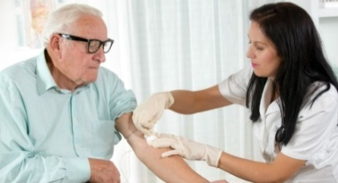 | Laser scanners to save …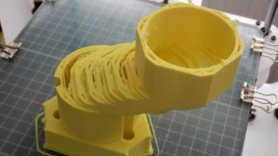 |  | 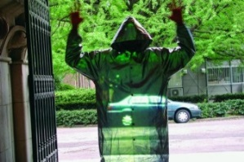  To create …
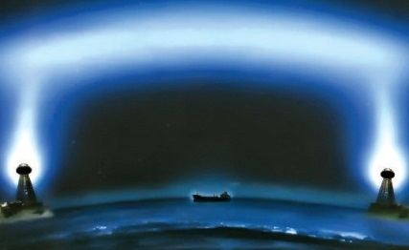  To transmit … |  | 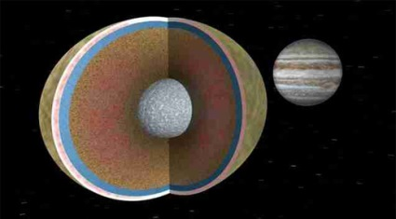  To … … in Jupiter's core

35 b Watch the video about the future use of lasers and fill in the gaps in the headings

35 с *Watch the video again and fill in the gaps in the projects’ descriptions
 | Description
5 | A device with two lasers: one makes a _____ _____ in your vein, the other _____ ___ the wound*. * рана
4 | Laser scanner compares the reference and the actual model to find the pieces
3 | _________ laser light joins together _______ into strings
2 | A high-powered laser creates a dense string of ____ __________. A second laser could follow this pathway without losing _________
1 | ________ high-powered lasers evaporated the hardest material on Earth – _________ __________
36 In groups of three, read one text each and find answers to the questions below. Present the project to your group.
TEXT 1

1. What current problem is this concept designed to solve?
2. What extra benefits will the laser technology bring?
3. What prevents this project from being realized?

In the mid-1990s the laser joined in a useful working partnership with the computer, but the laser still only reads, writes, and memorizes for the computer. Some scientists think the laser could go further and bring about a serious change in the way the computer is designed. The computer itself consists of wires, chips, connections, and other parts through which electrical signals flow. Experts point out that in the larger supercomputers sometimes too many pieces of information try to get to the same place at the same time. Due to the limitations of the machine parts themselves, the information bits can only move so fast. As a result, bottlenecks* form. These are like miniature traffic jams, only with bits of data instead of cars. The laser might be able to eliminate such bottlenecks by using light instead of electricity to process the information. A laser beam could carry millions of signals without once touching a physical connection. Thus bottlenecks would be eliminated and much more information could flow through the computer. Many technical problems need to be worked out before such an optical computer can be built. But researchers around the world are presently trying to solve these problems. (1216)

*bottleneck бутылочное горлышко, узкое место

Assess the projects on a 1 to 5 scale using the table.

 | Project 1 | Project 2 | Project 3
Importance
Practicability
Cost-effectiveness

TEXT 2
1. What current problem is this concept designed to solve?
2. What extra benefits will the laser technology bring?
3. What prevents this project from being realized?

Most nuclear scientists believe that in the future nuclear power will be supplied by fusion: a nuclear reaction in which two atoms are combined. One great benefit of controlling fusion for energy production is that the process is relatively clean and safe. All that is needed for fuel is a small amount of hydrogen. In addition, the process does not leak dangerous radiation.
But starting a fusion reaction requires an enormous initial force. Many scientists think that "laser chains" can supply that force. A laser chain consists of several laser amplifiers over a hundred feet long, which intensify the power of laser beams. The high-powered beams are directed at a tiny fuel pellet* from all sides at once. This causes an explosion powerful enough to trigger a fusion reaction.
Experiments with lasers and fusion began in the late 1960s, but progress was slow for a long time. A major breakthrough occurred in 2001 when researchers from Japan and the UK succeeded in using a laser beam to compress a ball-like pellet of nuclear fuel. The beam, which generated temperatures of 10 million degrees centigrade, focused on the pellet, creating enormous pressure—about 10 million times that of Earth's atmosphere. The pressure caused the pellet to implode (collapse inward) and release energy. (1190)

* fuel pellet топливная таблетка

Assess the projects on a 1 to 5 scale using the table.

 | Project 1 | Project 2 | Project 3
Importance
Practicability
Cost-effectiveness

TEXT 3
1. What current problem is this concept designed to solve?
2. What extra benefits will the laser technology bring?
3. What prevents this project from being realized?

The population of the world continues to grow rapidly, and more people create a demand for more energy. Today's major sources of energy are water power; the burning of coal, gas, and oil; and nuclear reactors. But all these methods may not be enough to supply the energy needs of the future.
The laser promises to open up new and seemingly endless stores of energy for humanity's use: the solar-powered satellite. The satellite will be rocketed into a special orbital position where it will always stay above a certain fixed point on Earth's surface. Once in position the satellite will begin gathering energy from sunlight. The energy will power a large laser that will direct a beam back to Earth where a receiver will collect the beam and convert it into electricity. If enough of these satellites can be put into orbit, a large share of Earth's energy needs will be met.
Some people worry that such a beam might be aimed in the wrong direction and cause death and destruction. As a matter of fact, the military has considered this method for making beam weapons. But ways will be found to adjust the power of the beam so that it will not do any damage. The time and money it will take to get these satellites orbiting will be worthwhile because sunlight is free. And because the sun is expected to shine for several billion more years, sunlight is also nearly inexhaustible*. (1376)

inexhaustible неисчерпаемый

Assess the projects on a 1 to 5 scale using the table.

 | Project 1 | Project 2 | Project 3
Importance
Practicability
Cost-effectiveness

37 Think of some common object or phenomenon (or ask your teacher for inspiration) and imagine what our life would be like without it. Let your groupmates guess what it is.
If we didn’t have (…)
If we didn’t have this, our shopping would take much longer.
If we didn’t have this, some medical manipulations would be more painful.
If we didn’t have this, we wouldn’t be able to create complex designs in mass production.

CONSOLIDATION
1 Translate the word combinations into English using the Active Vocabulary.
В наномасштабе
Все более сложный
Крошечные частички материи
Оптоволоконный провод
Полупроводниковый лазер
Прорывная технология
Связь посредством
Тонкая настройка
Выявлять дефекты
Дать начало инновациям
Изготовить первый лазер
Измерять мельчайшие изменения
Измерять расстояние
Использовать лазерную сварку
Подготовить почву для революции в промышленности
Предложить новую теорию
Присудить Нобелевскую премию
Проектировать лазерные устройства
Расплавлять металл
Усиливать сигнал

2 Identify the conditional type. Translate the sentences into Russian.
1. If I had bought $100 in bitcoin in 2010, it would have been worth $194,000,000 in 2018.
2. If the signal is too small, it will be amplified before connecting
3. We would all be safer and happier if all cars were autonomous.
4. If a self-driving cars causes an accident, who will be responsible?
5. If decisions about cars were rational, there would be a lot more tiny econoboxes on the road and a lot fewer SUVs.
6. If we could fly from our office, the trip to the airport would only take 8 minutes.
7. If laser had not been invented, many discoveries would never have happened.
8. If robots take over most jobs, what will be the purpose of humans?

3 Match the two halves of the sentences. Determine the conditional type. Translate into Russian.
If inexpensive lasers hadn’t been constructed, | you would have felt much more pain.
If laser wasn’t used in surgical operations, | a new era of laser machining would not have started.
If laser had not been used during the surgery, | recovery time would be longer.
Should you decide against the laser surgery, | complex design furniture would be more expensive.
If laser couldn’t reveal molecular structure, | it may take you longer to recover.
If the signal is transmitted via fiber-optic cables, | many scientific discoveries wouldn’t have occurred.
If laser machining didn’t become so widespread, | it will travel very fast.

4 Transform the sentences using the alternatives to IF.
As long as • in case • provided that • unless
1. The experiment will continue if there is enough funding.
2. The students will not enjoy the class if they don’t find the subject interesting.
3. Don’t start a full time job if you don’t need money badly.
4. You can do the assignment if you have a Moodle account.
5. If I don’t procrastinate, I will finish my PhD thesis this year.
6. If you are interested in languages, you could get a degree in linguistics at Bauman university.
7. We will receive the research funding, if we meet all the criteria.

